Parity Indoor Scavenger Hunt
Can you and your family collect all of the following items from around your home.
Tick off the items as you find them. Have fun!
Item | Picture | Found It!
A toy with wheels | 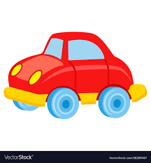
A book with the first letter of your name on it | 
A pair of matching socks | 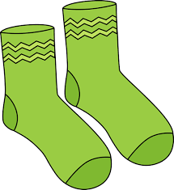
4 things that are green | 
Something very soft | 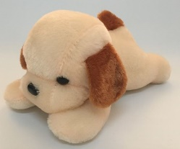
A toy that fits in your hand | 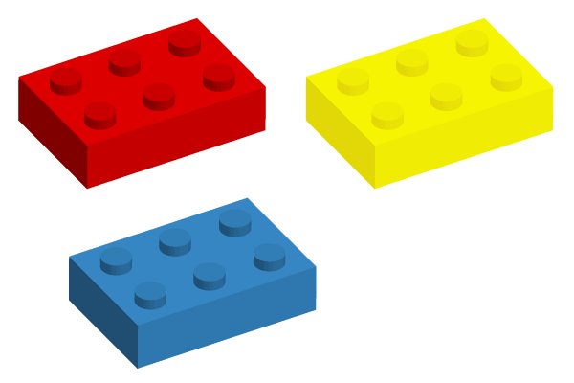
Something round | 
A book with numbers on it | 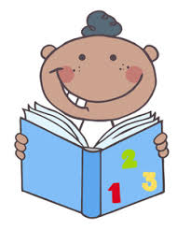
A picture of someone you love | 
Something cosy | 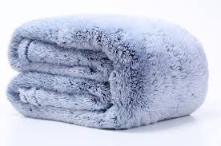
A toy with 3 different colours on it | 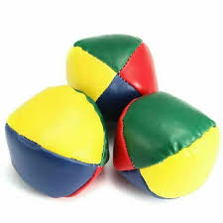
Your favourite soft toy | 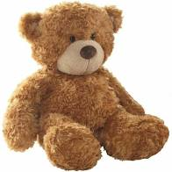
Odd Socks | 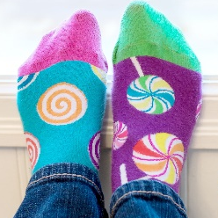
A button | 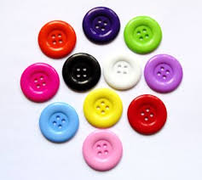
A marble | 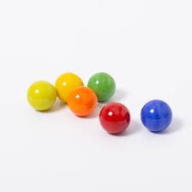
A piece of jigsaw | 
Well done! How many did you find?
Don’t forget to put them all back where you found them.
Thanks for playing the Parity Indoor Scavenger Hunt, see you again soon!

