Sensory investigations

What is on Jack the cats head? Collect the items from outside and see which one matches. Do they smell? What do they feel like?
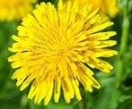
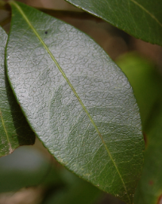

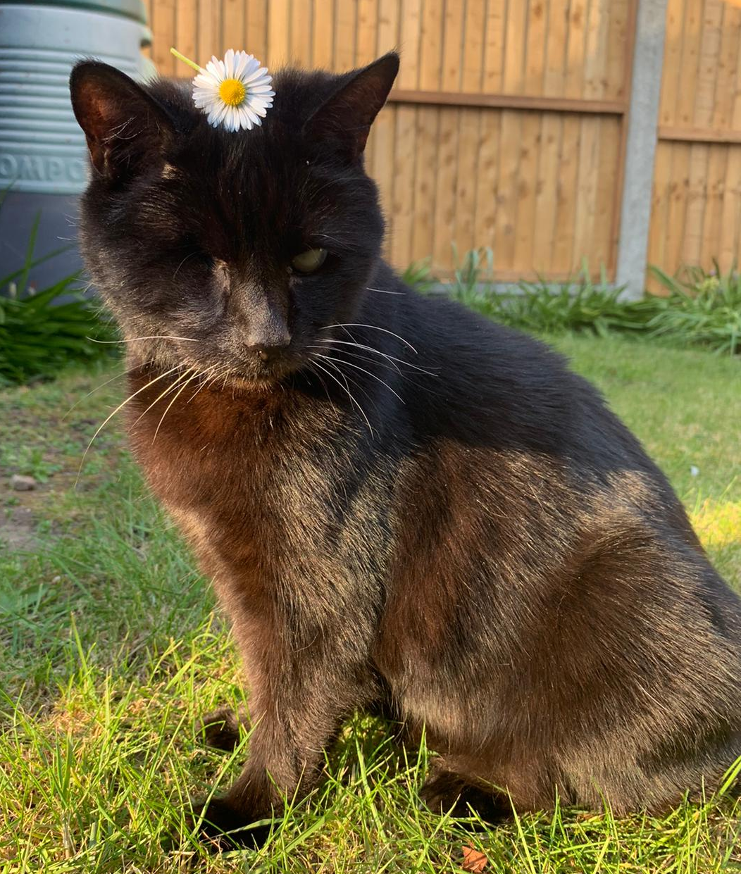

Gather some ice from your freezer, what does it feel like? What happens if you leave it out of the freezer?
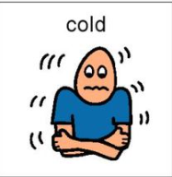
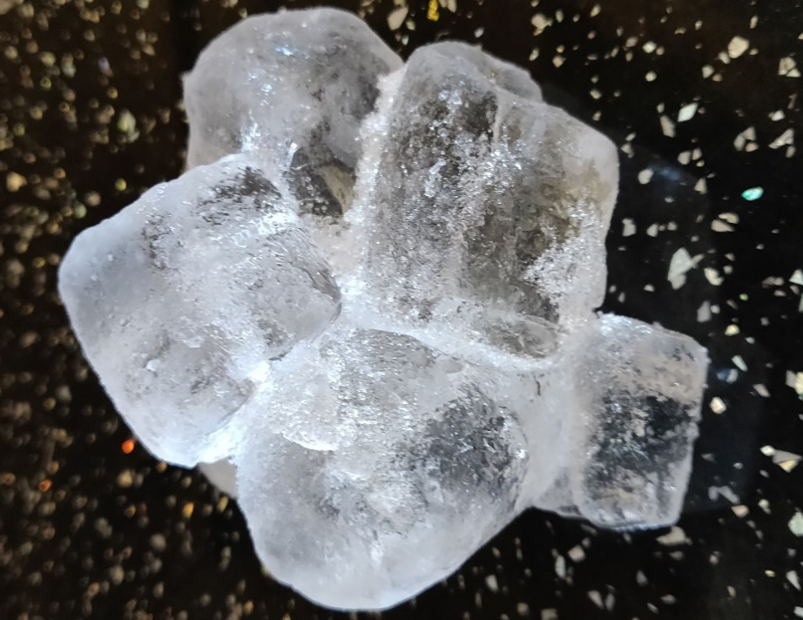

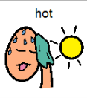

Water; put your hands or your feet in some water, is it WET or DRY.
If you are able, what does it taste like? If you add flavours, do you prefer it with flavour?
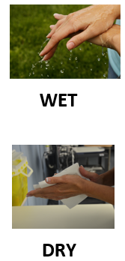
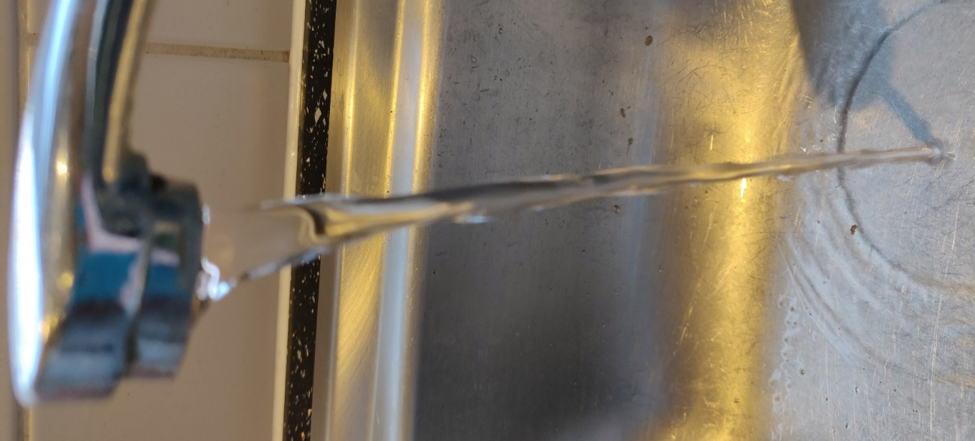
Do the flavours smell?
What colour are they?

Dried Pasta, touch it. What does it feel like? Hard or Soft?
If you put this in warm water, does the texture change? Is it Hard or Soft now?



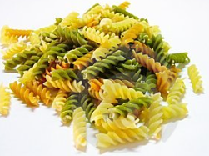

Flour – Is it sticky or dusty?
What happens if you add water to the flour? Is it sticky or dusty?
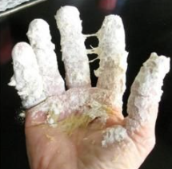
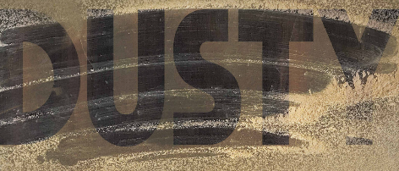
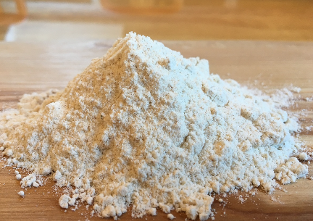

Sound and noise.
When you bang the drums is it loud or quiet?


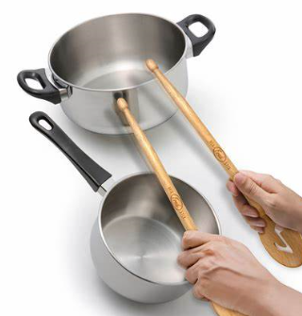

When you tap, your leg is it loud or quiet?
