A to Z of Fundraising Ideas
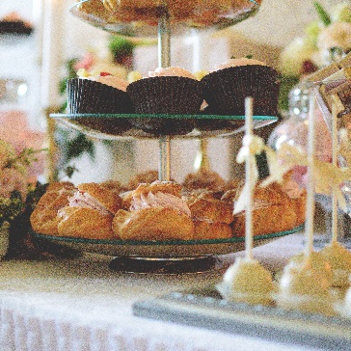
- Abseil
- Afternoon Tea
A


B
- Bake Sale
- Birthday


C
- Coffee Morning
- Car Wash


D
- Dress Down Day
- Dance Contest

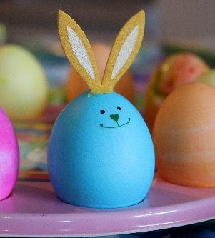
- Eighties Night
- Easter Party

E


F
- Film Night
- Five-a-side Football


G
- Games Night
- Give It Up


H
- Head Shave
- Halloween Party

I

- Irish Night
- Ice Party


- Jumble Sale
- Jazz Night
J

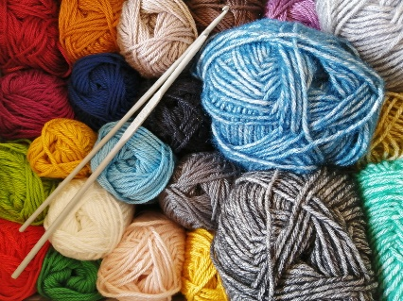
K
- Karaoke Night
- Knitting

L
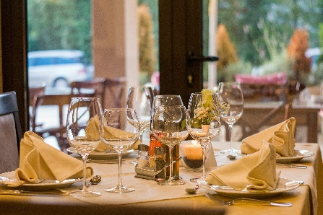
- Ladies’ Night
- Lunch with Friends


- Marathon
- Music Night
M


N
- Nature Trail
- Non Uniform Day

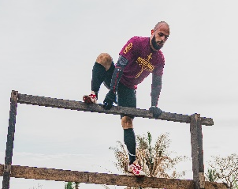
- Obstacle Course
- Open Garden/Day
O

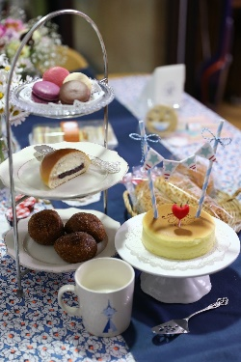
- Pamper Day
- PariTea for Disability
P

Q

- Quiz Night
- Quilt-making


- Raffle
- Race Night
R


S

- Shop Online
- Skydive


- Tombola
- Tough Mudder
T


U
- Upcycle
- Unwanted Gifts Donated to our Shops


V
- Valentines
- Vegetable Sale


W
- Wing Walk
- Wear It


X
- Xmas Fayre
- X Marks the Spot
Treasure Hunt


Y
- Yoga
- Year Long Challenge

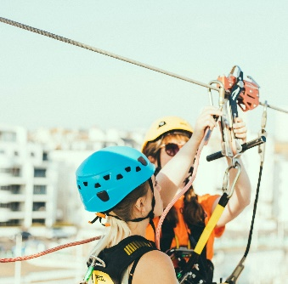
- Zumbathon
- Zip Wire

Z

Hope these thoughts have given you an idea of ways you might support us.
However if you have another idea we’d love to hear from you!

For more information,
Please contact Community Fundraiser Emma Nelson on 01252 375 581 or e-mail emma.nelson@parityfordisability.org.uk
Thank You

Registered Charity Number: 1071571

