

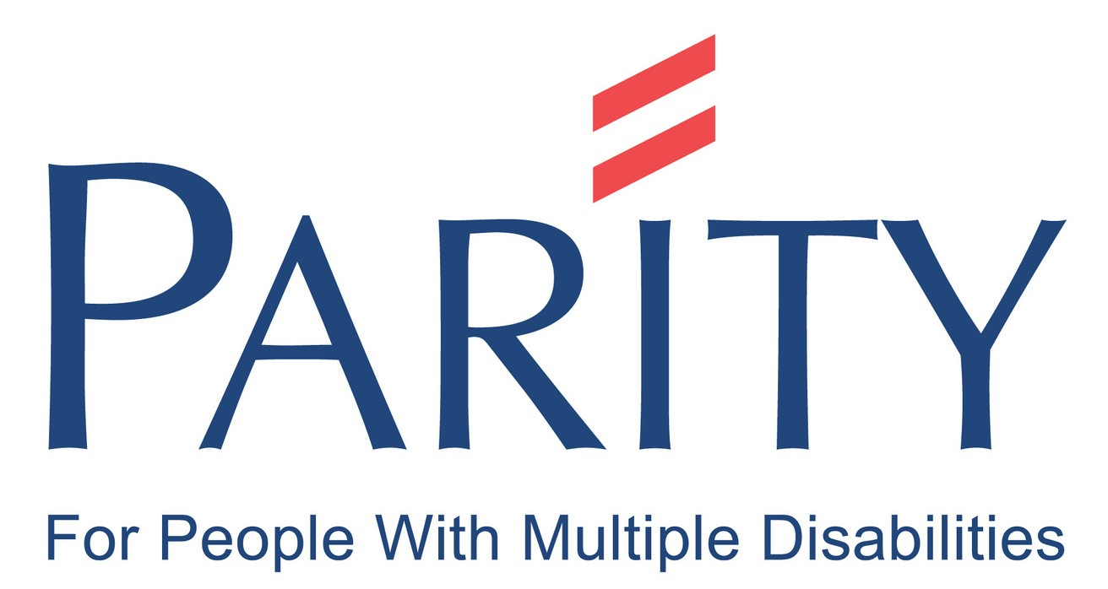

FUNDRAISING PACK

www.parityfordisability.org.uk


THANK YOU

Welcome to Team Parity!
We’re excited that you have chosen to fundraise and support our vital services for adults with multiple disabilities.
Our mission is to provide the people who rely on our services with the necessary specialised staff, flexible transport, tailored space, equipment and technologies to build friendships and networks, use and develop skills, participate, contribute to their community - in fact, do what everyone else is doing.

You can read more about the students and our impact at www.parityfordisability.org.uk, and by following us on Facebook and Instagram.

FUNDRAISING IDEAS


How to get involved? Here are some ideas to get you started...

Auction
Cake Sale

Eighties Night

Bike Ride



Fancy Dress Garage Sale
Halloween Party

Dress Down Day

- Coffee Morning
- Bingo

Stall at Fete

10K Run

Garden Party

Why not pick an idea from our list or try one of these...




Get together with friends and head up a fun quiz either in person or virtually. Charge a small entry fee to raise funds.
Hold a gathering of family, friends or colleagues. Those who want to, bring a cake or other goodies and everyone makes a donation.



Are you creative? Make your own cards or something quirky, and sell to your family and friends or via social media.
Take on your own fitness challenge.
Walking, squats, yoga or even a dance marathon. Set yourself a target and ask for sponsorship.

FUNDRAISING AT WORK
If you want to try fundraising on the job, here are ideas that fit into a workplace environment and your busy schedule.

Dress Down Day

Ask your colleagues to get rid of their suits and jackets and ask for a £2 donation per person.

Collection Tins
Put a collection tin in your office or canteen and send an e-mail round to colleagues to let them know.

Matched Giving
Some companies offer matched giving to employees, meaning that you could double your donation total. Don't forget to ask if they will nominate us for their Charity of the Year.

Payroll Giving
Does your company offer Payroll Giving? It's a simple, tax-effective way for employees to give to Parity directly from their payslip each month. Ask your employer for more details.

Bake Sale, AKA PariTea for Disability

Gather round the water cooler with a cup of tea and a slice of cake to break up the day. Ask colleagues to bring in a sweet treat and a small donation.

Last Hours Pay
Celebrate your last hour of the month. Just donating an hour of your time will make a difference.

Raffle

Create an office raffle with original prizes – maybe an extra day’s holiday? Or punters guess how many sweets in a jar, instead of buying raffle tickets.

Don't Send Me a Card
A great environmentally friendly way to send cards virtually. Choose a card, write your message, choose your donation amount and send. A simple but effective way to support Parity.

Shop Donation Drive
Ask colleagues to bring in an item, clothing, bags, shoes or other items to donate. Create a collection point in the office and we can arrange to get the donations to Parity's shops.

FUNDRAISING IN THE COMMUNITY
If you’re a local group, club, trader or network, we would love to hear from you.

Pub quiz
Are you a pub landlord and looking for a charity to support? Nominate Parity to benefit from a quiz with your regulars.

Show or Performance
Are you in an instrumental group, dance troupe, choir, dramatic society or involved any sort of performing? Please use your talent in support of award-winning Parity for Disability.

Coffee Morning and Talk

Get together and have a natter with a coffee and a slice of cake. You could also consider inviting someone to give a talk. Ask attendees to donate.

Car Wash
If your organisation has access to a suitable outdoor space, you could roll your sleeves up and organise a community car wash.

FUNDRAISING & PROMOTION
If you choose to take on a challenge or fundraising activity, make sure you let everyone know about it. Asking for sponsorship is also a great way to get your friends, family, colleagues and others involved with what you are doing.

Things to do...

Set a fundraising target Set up an online giving Share your story/page
Give regular updates e.g. photos


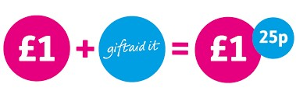

Within a few minutes you can create an online fundraising page. We recommend using JustGiving. To get started search for justgiving.com/parityfordisability
Don't forget to encourage your sponsors to Gift Aid their donation if they are a UK tax payer - we can claim an extra 25p per £1 donated.

You can also raise money offline. If you have people wanting to support you who are not online, just use our printed sponsorship form and ask them to fill in their details.
Once your challenge or event has finished, send the form with the sponsorship money to the Parity office.

SOCIAL MEDIA




Let everyone know about your challenge or event.

Take advantage of social media as it's a great FREE way to spread the word not just about what you are doing but also about Parity for Disability and the vital services that we provide for adults with profound and multiple disabilities.

Use your social media profile to post regular updates and share images of your challenge or event.

Use Twitter to contact the local community and tag as many people as you can - encourage retweets!

Post links to your sponsorship page regularly.

Don't forget to tag Parity, we love to hear about your progress!
Twitter: @ParityFD
FB: facebook.com/ParityforDisability Instagram: @parityfordisability

RULES
& REGULATIONS


It’s really important when you’re holding your event that you comply
with any rules that might apply.

Health and Safety - make sure to carry out a risk assessment to identify any risk your event may encounter. Make sure you know what to do in an emergency e.g. administer first aid, find fire exits.

Food and Alcohol - if you are providing food and drink make sure to comply with all regulations. For more information visit food.gov.uk


Lotteries and Raffles - rules surrounding lotteries and raffles can be quite complex. Make sure that you are up to date by visiting gamblingcommission.gov.uk

Licences - A few activities require a licence, for example, those relating to alcohol, live music, or holding a collection. Some venues already have these in place however please check with your local authority for licences that you may need.

FUNDS RAISED

WHAT TO DO NOW...
So you’ve held your fundraiser – congratulations! There are easy ways to send us any hard-earned donations that were given to you directly.

Send a cheque to our office
Please make payable to

Parity for Disability
Send to us at: 94 Whetstone Road, Cove, Farnborough, Hampshire, GU14 9SX

Send via our website
Go to...
parityfordisability.org.uk/donate/


Pay directly into our bank account
CAF Bank
Sort Code: 40-52-40
Account Number: 00012044
Please put your name as a reference and notify fundraising@parityfordisability.org.uk

OTHER WAYS TO GET INVOLVED

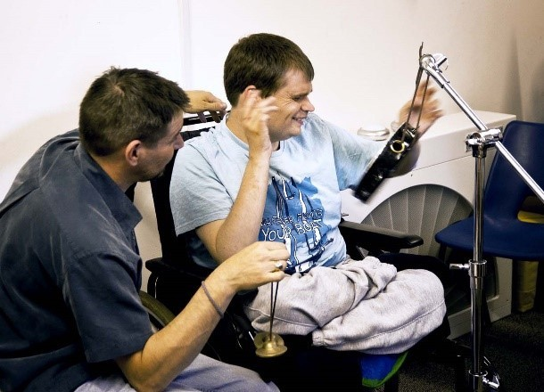

Volunteer with us
From volunteering within our shops to helping out with fundraising events, there are many opportunities to get on board.

Sign up for our newsletter
Join our mailing list on any page at www.parityfordisability.org.uk, or contact us by phone or email to let us know you want our updates.

Use social media
A quick and easy way to support Parity is to follow us on various social media platforms and share our posts, increasing our reach and letting more people know about us.

Excellence in services and support for people with multiple disabilities

Parity for Disability 94 Whetstone Road Cove
Farnborough Hampshire GU14 9SX

Tel: 01252 375 581

Any questions, please contact
fundraising@parityfordisability.org.uk

www.parityfordisability.org.uk
Registered Charity Number: 1071571

